Polygonal Shapes
# Source: AI Source: Provided by: [Data Path: Persons Table -> ID Column: 1, Name_En Column: Motasem Essam] -> From: [ChatGPT] on [7/25/2026]
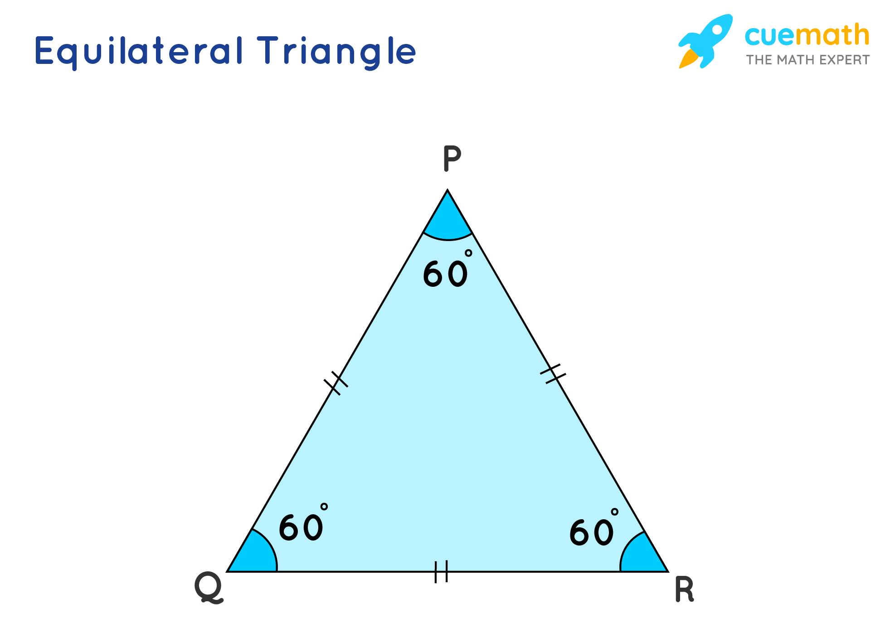
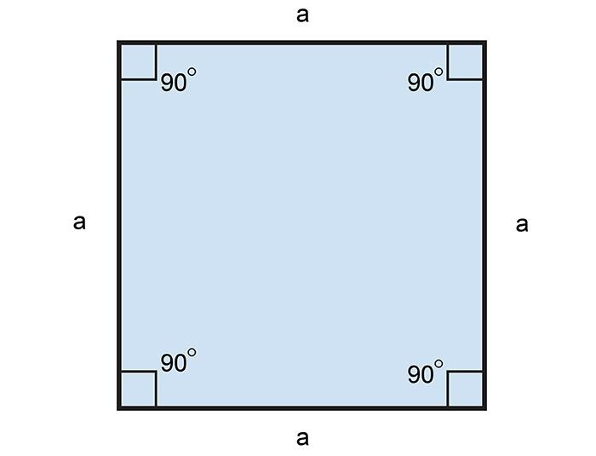
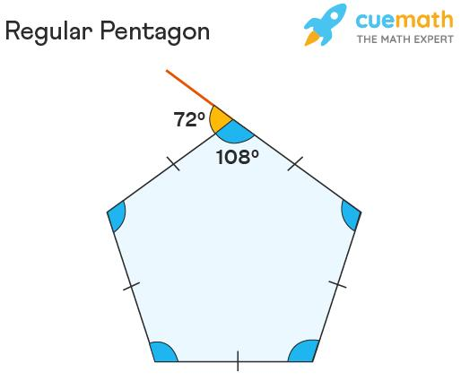
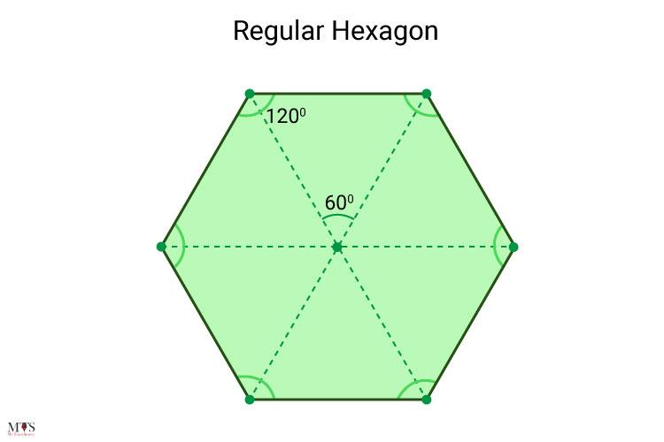
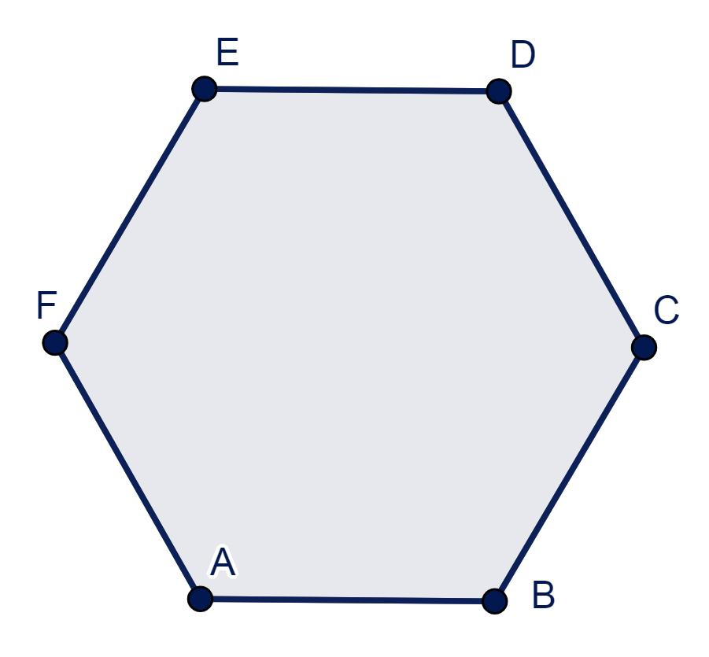

Definition
# Source: AI Source: Provided by: [Data Path: Persons Table -> ID Column: 1, Name_En Column: Motasem Essam] -> From: [ChatGPT] on [7/25/2026]
A Polygonal Shape is a closed two-dimensional geometric figure formed entirely by straight line segments. These line segments meet only at their endpoints, called vertices, to form a continuous closed boundary.
The word polygon comes from the Greek words:
- Poly = many
- Gonia = angles
Therefore, a polygon is literally a many-angled figure.

Characteristics
# Source: AI Source: Provided by: [Data Path: Persons Table -> ID Column: 1, Name_En Column: Motasem Essam] -> From: [ChatGPT] on [7/25/2026]
A polygonal shape:
- Is two-dimensional (2D).
- Is formed only by straight line segments.
- Is closed (its first and last vertices coincide).
- Has a finite number of sides.
- Has a finite number of vertices.
- Has interior angles and exterior angles.
- Encloses a bounded region.
- Does not contain curved edges.

Illustration

Triangle
# Source: AI Source: Provided by: [Data Path: Persons Table -> ID Column: 1, Name_En Column: Motasem Essam] -> From: [ChatGPT] on [7/25/2026]
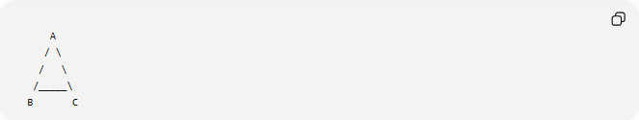
A
/ \
/ \
/_____\
B C
Sides:
- AB
- BC
- CA

Quadrilateral
# Source: AI Source: Provided by: [Data Path: Persons Table -> ID Column: 1, Name_En Column: Motasem Essam] -> From: [ChatGPT] on [7/25/2026]
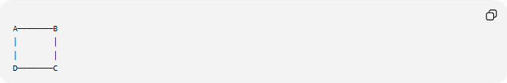
A────────B
│ │
│ │
D────────C
Four straight sides form a polygon.

Pentagon
# Source: AI Source: Provided by: [Data Path: Persons Table -> ID Column: 1, Name_En Column: Motasem Essam] -> From: [ChatGPT] on [7/25/2026]
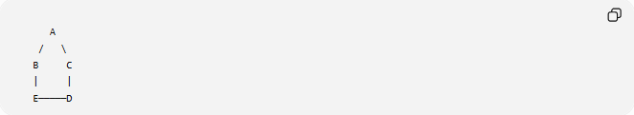
A
/ \
B C
| |
E─────D
Five connected straight sides.

Mathematical Representation
# Source: AI Source: Provided by: [Data Path: Persons Table -> ID Column: 1, Name_En Column: Motasem Essam] -> From: [ChatGPT] on [7/25/2026]
A polygon with vertices
$$P_{1},P_{2},P_{3},…,P_{n}$$
is formed by the line segments
$$\overline{P_{1}P_{2}},\overline{P_{2}P_{3}},…,\overline{P_{n}P_{1}}$$
The last segment returns to the starting point, making the figure closed.

Basic Elements of a Polygon
# Source: AI Source: Provided by: [Data Path: Persons Table -> ID Column: 1, Name_En Column: Motasem Essam] -> From: [ChatGPT] on [7/25/2026]
Every polygon has:
- Sides
- Vertices
- Interior angles
- Exterior angles
- Boundary
- Interior region

Classification by Number of Sides
# Source: AI Source: Provided by: [Data Path: Persons Table -> ID Column: 1, Name_En Column: Motasem Essam] -> From: [ChatGPT] on [7/25/2026]
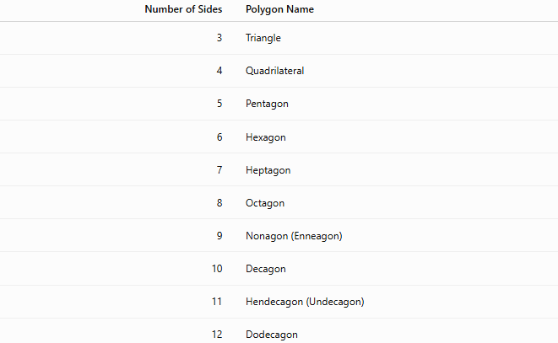
Number of Sides | Polygon Name
3 | Triangle
4 | Quadrilateral
5 | Pentagon
6 | Hexagon
7 | Heptagon
8 | Octagon
9 | Nonagon (Enneagon)
10 | Decagon
11 | Hendecagon (Undecagon)
12 | Dodecagon

Regular Polygon
# Source: AI Source: Provided by: [Data Path: Persons Table -> ID Column: 1, Name_En Column: Motasem Essam] -> From: [ChatGPT] on [7/25/2026]
A Regular Polygon has:
- Equal side lengths.
- Equal interior angles.
Examples:
- Equilateral triangle
- Square
- Regular pentagon
- Regular hexagon

Irregular Polygon
# Source: AI Source: Provided by: [Data Path: Persons Table -> ID Column: 1, Name_En Column: Motasem Essam] -> From: [ChatGPT] on [7/25/2026]
An Irregular Polygon has:
- Unequal side lengths and/or
- Unequal interior angles.
Examples:
- Scalene triangle
- General quadrilateral
- Irregular pentagon

Convex and Concave Polygons

Convex Polygon
# Source: AI Source: Provided by: [Data Path: Persons Table -> ID Column: 1, Name_En Column: Motasem Essam] -> From: [ChatGPT] on [7/25/2026]
A polygon where every interior angle is less than
$${180}^{∘}$$
and every diagonal lies completely inside the polygon.
Example:
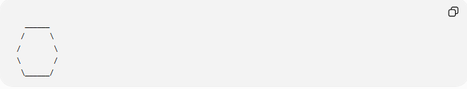
______
/ \
/ \
\ /
\______/

Concave Polygon
# Source: AI Source: Provided by: [Data Path: Persons Table -> ID Column: 1, Name_En Column: Motasem Essam] -> From: [ChatGPT] on [7/25/2026]
A polygon with at least one interior angle greater than
$${180}^{∘}$$
Example:

______
/ \
/ __ \
\__/ \__/

Interior Angle Sum
# Source: AI Source: Provided by: [Data Path: Persons Table -> ID Column: 1, Name_En Column: Motasem Essam] -> From: [ChatGPT] on [7/25/2026]
For a polygon with
$$n$$
sides:
$$\boxed{\left(n-2\right)×{180}^{∘}}$$
Examples:
Triangle:
$${180}^{∘}$$
Quadrilateral:
$${360}^{∘}$$
Pentagon:
$${540}^{∘}$$
Hexagon:
$${720}^{∘}$$

Exterior Angle Sum
# Source: AI Source: Provided by: [Data Path: Persons Table -> ID Column: 1, Name_En Column: Motasem Essam] -> From: [ChatGPT] on [7/25/2026]
For every polygon:
$$\boxed{{360}^{∘}}$$

Real-World Examples
# Source: AI Source: Provided by: [Data Path: Persons Table -> ID Column: 1, Name_En Column: Motasem Essam] -> From: [ChatGPT] on [7/25/2026]
Polygonal shapes appear in:
- Buildings.
- Windows.
- Tiles.
- Road signs.
- Chessboards.
- Tables.
- Books.
- Packaging.
- Honeycomb cells (hexagons).
- Football field markings.

Applications
# Source: AI Source: Provided by: [Data Path: Persons Table -> ID Column: 1, Name_En Column: Motasem Essam] -> From: [ChatGPT] on [7/25/2026]
Polygonal shapes are used in:
- Plane Geometry
- Coordinate Geometry
- Engineering
- Architecture
- Surveying
- CAD (Computer-Aided Design)
- Computer Graphics
- GIS (Geographic Information Systems)
- Robotics
- Industrial Design

Advantages
# Source: AI Source: Provided by: [Data Path: Persons Table -> ID Column: 1, Name_En Column: Motasem Essam] -> From: [ChatGPT] on [7/25/2026]
Studying polygonal shapes helps to:
- Compute area and perimeter.
- Analyze angles.
- Model engineering structures.
- Design buildings and objects.
- Understand symmetry and tessellations.
- Solve geometric problems.

Limitations
# Source: AI Source: Provided by: [Data Path: Persons Table -> ID Column: 1, Name_En Column: Motasem Essam] -> From: [ChatGPT] on [7/25/2026]
Polygonal shapes:
- Contain only straight edges.
- Cannot exactly represent smooth curved objects.
- May require many sides to approximate a circle.

Comparison with Other Shape Types
# Source: AI Source: Provided by: [Data Path: Persons Table -> ID Column: 1, Name_En Column: Motasem Essam] -> From: [ChatGPT] on [7/25/2026]
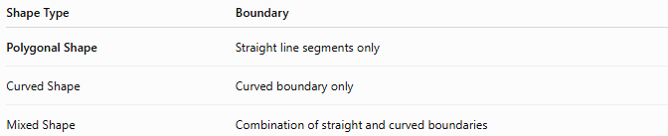
Shape Type | Boundary
Polygonal Shape | Straight line segments only
Curved Shape | Curved boundary only
Mixed Shape | Combination of straight and curved boundaries

Key Points
# Source: AI Source: Provided by: [Data Path: Persons Table -> ID Column: 1, Name_En Column: Motasem Essam] -> From: [ChatGPT] on [7/25/2026]
- A Polygonal Shape is a closed figure made entirely of straight line segments.
- It has:
  - Sides
  - Vertices
  - Interior angles
  - Exterior angles
- Polygonal shapes may be:
  - Regular or irregular
  - Convex or concave
- Common examples include triangles, quadrilaterals, pentagons, hexagons, and octagons.

Conclusion
# Source: AI Source: Provided by: [Data Path: Persons Table -> ID Column: 1, Name_En Column: Motasem Essam] -> From: [ChatGPT] on [7/25/2026]
A Polygonal Shape is a closed two-dimensional figure constructed entirely from straight line segments joined end to end. Polygonal shapes form the foundation of plane geometry and include familiar figures such as triangles, quadrilaterals, pentagons, and hexagons. They are essential in coordinate geometry, engineering, architecture, surveying, CAD, computer graphics, GIS, robotics, industrial design, and mathematics, where they are used to analyze shapes, compute areas and perimeters, design structures, and model real-world objects.

